**Convert .jpg image file to .png:**

The goal is to create a system that automates image conversion between two formats using AWS services. Key functionalities include converting jpg to png.

*AWS services used*:

**Amazon S3**: For storing the input and output images.

**AWS Lambda**: For executing the conversion logic in a serverless manner.

**Amazon SQS**: For managing the workflow and communication between different components.

*Detailed Workflow*:

1. **Setting up Amazon S3 bucket**: Create a bucket to store the input and output data.
2. **Create AWS lambda function**: This lambda function will process the conversion logic and store the converted image in the same bucket.

Below is the functional Lambda Code for Image conversion:

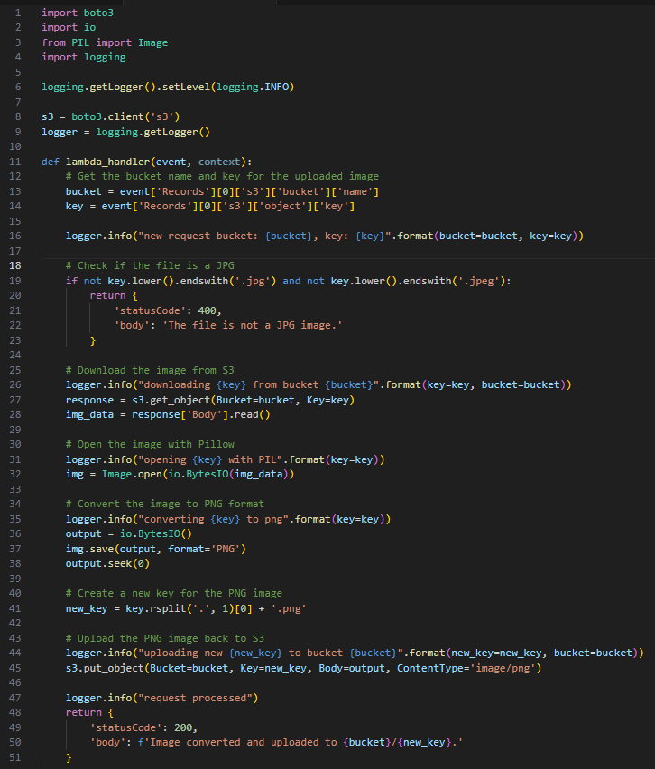

** Pillow (for image processing) should be included in the deployment package.

You’ll encounter an error: ***cannot import name '_imaging' from 'PIL'***

1. Look for your python version in the repository - <https://github.com/keithrozario/Klayers/tree/master/deployments>
2. Select the region and open the HTML file in which your lambda is running.
3. Get the ARN of the latest pillow version 🡪 Go to your Lambda Function 🡪 Add the layer by specifying the ARN 🡪 Save.

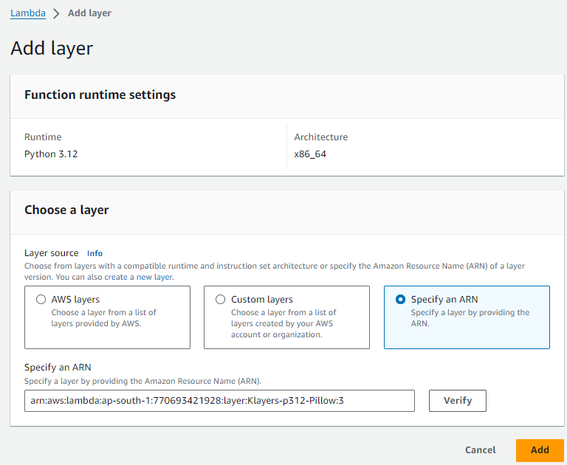

**Event JSON**:

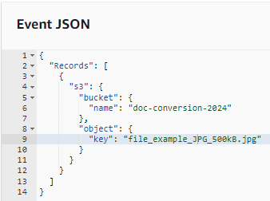Adjust the bucket name

Key is the image file name.

Run the code:

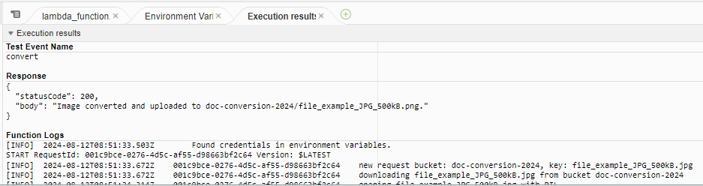

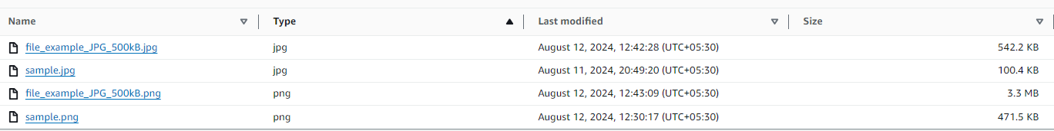

Image uploaded is successfully converted to .png format.

**Add Triggers**:

When the document is uploaded in S3, the lambda to convert image is triggered and stored into the bucket.

**Add Destination:**

(AWS Lambda works only with Standard SNS topics – So create SNS topic of type ‘Standard’)

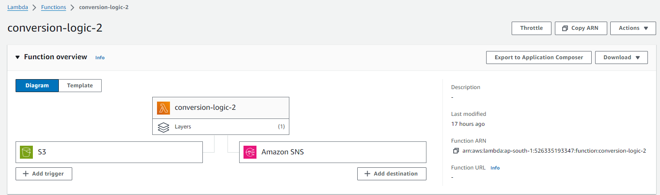

*Additional configuration*: **Update S3 bucket policy**

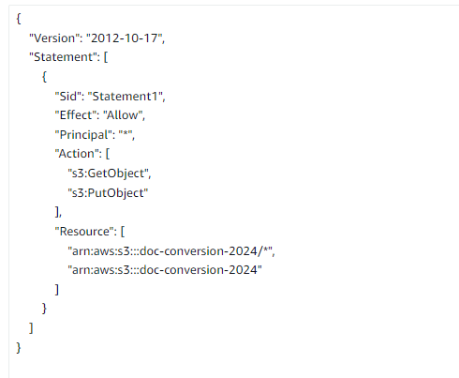

**Final Output**:

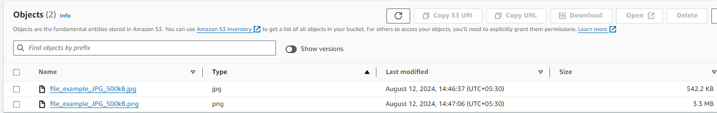

After 30 seconds of processing and converting the image from jpg to png, the image uploaded in S3 in .jpg format is converted to .png format and again uploaded to bucket. Additionally, the user is notified of the actions successfully performed.

